Stage 3 Physics:
Motion and Force in a Gravitational Field
Student workbook Part 2: TEACHER’S GUIDE

Contexts:
- Movement in sport, funfairs and play-grounds
- Motion of satellites, planetary motion and the universe
- Structures, bridges and buildings

Plan For Unit.
This workbook will give you an outline of the content to be covered and the related text pages. It is expected that you will follow the workbook and read the related text, experiments and investigations before the lesson. It will be assumed that you have read the text and have some introductory knowledge of the work to be covered each lesson; failure to do so may affect your progress in class. Your teacher will then teach you the concepts and show you how to do the examples in the workbook thus ensuring you have exemplars when completing additional questions from the workbook and texts. Your teacher also has all the worked answers to the additional questions in this workbook and you must check your answers when you complete the questions.

In addition to the work set for homework, it is essential that you set up a study plan and regularly review the work covered. This plan should be set up from day one. Regular reviewing not only makes study easy, it ensures good grades.

Wk | Content | Text Reference | Exploring Physics |  | Assessments
Wk | Content | Text Reference | Problem Sets | Experiments & Investigations | Assessments
1 | Students start Monday  - describe and apply the principle of conservation of energy  - resolve, add and subtract vectors in one plane  - draw free body diagrams, showing the forces acting on objects, from descriptions of real life situations involving forces acting in one plane  - explain and apply the concept of centre of mass | CD Pg. 416-419  CD Pg. 421  CD Pg. 420
2-3 | - describe and apply the concepts of distance and displacement, speed and velocity, acceleration, energy and momentum in the context of motion in a plane, including the trajectories of projectiles in the absence of air resistance—this will include applying the relationships:  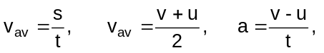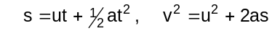  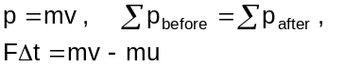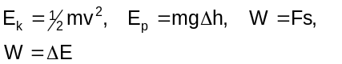  - describe qualitatively the effects of air resistance on projectile motion | Stage 2 Review  CD Pg. 422-432  CD Pg. 433-444  Pg. 7-14  Pg. 19-22  Pg. 26-32

Wk | Content | Text Reference | Exploring Physics |  | Assessments
Wk | Content | Text Reference | Problem Sets | Experiments & Investigations | Assessments
4 | - explain and apply the concepts of centripetal acceleration and centripetal force, as applied to uniform circular motion—this will include applying the relationships: 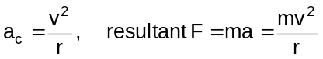 | Pg. 33-51
5 | Week 5 Monday Holidays  - describe and interpret the radial gravitational field distribution around a single (point) mass  - explain and apply Newton's Law of Universal Gravitation and the concept of gravitational acceleration, g, as gravitational field strength—this will include applying the relationships: 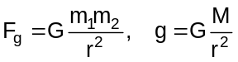 | Pg. 58-62  Pg. 54-62 |  |  | Task 6: Test Projectile motion and circular motion
6 | - explain the conditions for a satellite to remain in a stable circular orbit in a gravitational field, and calculate the parameters of satellites in stable circular orbits—this will include applying the relationships:  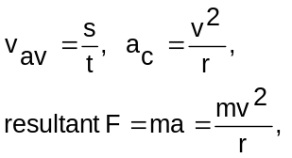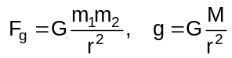.  - describe and explain the impact of satellites and associated technologies on everyday life | Pg. 63-68  Pg. 68-71
7-8 | - explain and apply the concept of torque or moment of a force about a point, and the principle of moments, and their application to situations where the applied force is perpendicular to the lever arm—this will include applying the relationships: 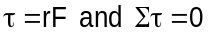 .  - explain and apply the concept of a rigid body in equilibrium—this will include applying the relationships: 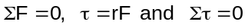  Unit Test | Pg. 72-76  Pg. 77-91 |  |  | Task 7: Test Motion and forces in a gravitational field

Outcome 7: explain and apply the concepts of centripetal acceleration and centripetal force, as applied to uniform circular motion—this will include applying the relationships:

Going Around In Circles

Going Around at a Constant Speed Text Reference pg. 33-36
An object moving in a circle may travel with constant speed, but its velocity will be constantly changing because its direction of motion is constantly changing. Because the velocity is changing, the object will be accelerating. As there is acceleration there must be a net force acting to produce the circle motion.

There are two types of motion:
a. Uniform circular motion where there is a constant speed

b. Non-uniform circular motion where a change of speed occurs.

For this unit we will only consider motion (a)
Terminology and Equations:
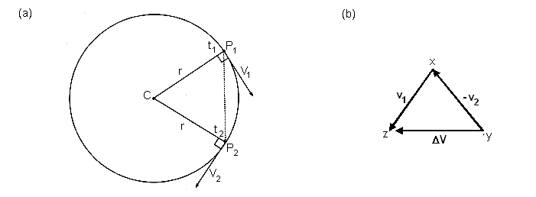
- The radius (r) is a position vector acting out from the centre.
- The velocities (V₁ and V₂) are a tangent to the circle, and at right angles to the radius.
- Diagram (b) shows the change in velocity or acceleration (a).
- The acceleration is always towards the centre.
- The time (t) taken to move once around the circle is called the period (T).
- The frequency (f) can be found by 1/T.
- The distance travelled is the circumference of the circle - 2πr therefore 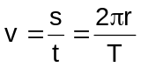
Your teacher will work through this example with you.
Example:
You may feel like you are not moving but the earth takes one year to complete its revolution around the sun. Assuming it moves at a constant speed in a circle at a distance of 1.50 x 10⁸ km from the sun, at what speed does the earth travel in kms⁻¹.

r = 1.5 x 10⁸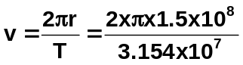 km
T = 1 year
= 365 x 24 x 60 x 60
= 3.154 x 10⁷ s v = 29.9 kms⁻¹

Equations for acceleration:
Equation for centripetal acceleration is 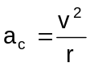

Using main equation and substituting in other equations for v and r, two other equation can be found.

a_{c} = v² a_{c} = 4π²r a_{c} = 2πv
r T² T
substitute v = 2πr substitute r = vT
T 2π

Example:
A side show attraction is racing cars. Assuming that the track is circular and that a boy is driving a car at an average velocity of 20.0 kmh⁻¹, 3.00 m from the centre, what is the size of the acceleration to move around the track? (Helpful hint: Don’t forget to change to SI units.)

v = 20 kmh⁻¹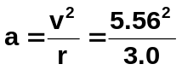
= 5.56 ms⁻¹
r = 3.0 m
a = 10.3 ms⁻²

Centripetal Force:
As shown before, because acceleration occurs in circular motion, there must be a force acting and this must act along the direction of the acceleration e.g. towards the centre. This centre-seeking force is called the centripetal force. As the force and acceleration are in the same direction we can now call our acceleration the centripetal acceleration, a_{c}.

We know from Newton’s Second Law that F = ma

Now in the case of centripetal acceleration, a_{c} = 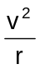
Therefore F_{c} = 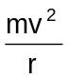 which is the equation for the centripetal force

Note also as v = 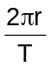 then in addition, F_{c} = 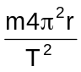

Example:
Annie rides her bicycle at a constant speed around a circular track of radius 50.0 m. She completes one revolution of the track each minute.
a. What is her speed?  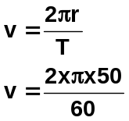  v = 5.24 ms⁻¹ | b. What is the magnitude of the centripetal acceleration acting on the rider?  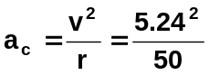  a_{c} = 0.548 ms⁻² | - If the rider and cycle have a combined mass of 70.0 kg, what is the size of the force causing the circular motion?  F_{c} = ma  = 70 x 0.548  F_{c} = 38.4 N

Centrifugal – An outward directing force?
Writers will often describe a centrifugal force or centre-fleeing force. “A centripetal force”, they say “acts towards the centre of the circle, so there must be a force acting away from the centre – we can feel it so it must exist.” IT DOES NOT!!

Let us consider Newton’s First Law – objects will keep doing what they are doing unless acted upon by an external force. As the velocity of an object travelling in a circle is at a tangent to the circle so is the direction of travel. While the external force keeps acting, the object will keep travelling in a circle. If the external force is no longer available then the object will shoot off at a tangent to the circle NOT away from the centre. So although you may be able to feel a force acting away from the centre, for the reason above, physicists call it a “fictitious force” unlike the forces of gravity, etc.

Back to Centripetal Forces Text Reference pg. 36
Examples of Centripetal forces are:
- Loops in roller coaster.
- Rides at the Royal Show
- Buses or cars suddenly turning a corner
- Many sports such as hammer throwing
- Gravitational attraction between Earth and Moon.
- Planes doing loops in the air

Your teacher will work through the examples on the following pages with you.

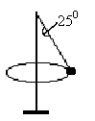
Example:
In a game of totem tennis, a 0.120 kg ball is moving at a constant velocity in a horizontal circle around the pole as shown. The rope forms an angle of 25.0⁰ to the pole and the horizontal radius of the ball is 1.20 m. The ball takes 0.800 s for one revolution.
- Draw and label the forces acting on the ball.
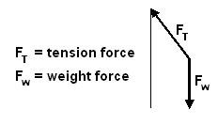

Helpful Hint: The centripetal force is a resultant force of the tension and weight force so should not be shown on diagrams. In the 2008 TEE, students showing the centripetal force had one mark deducted.

- What is holding the ball up? Vertical component of the tension force, equal in magnitude to the weight force.
- What is the ball’s acceleration?

r = 1.2 m 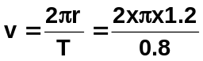 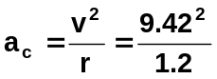
T = 0.8 s v 9.42 ms⁻¹ a_{c} = 73.9 ms⁻²

- What is the tension in the string?

F_{w}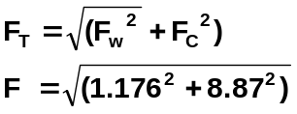 = 0.12 x 9.8
= 1.176 N
F_{c} = ma_{c}
= 0.12 x 73.9
= 8.87 N F_{T} = 8.95 N

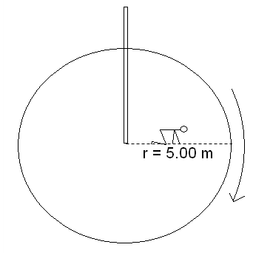
Example:
A fun ride at the Busselton Show consists of a giant disk, which rotates, in a horizontal plane. While the disk is stationary, the riders sit in the centre of the disk. When the disk is rotating at full speed, the riders must start to crawl towards the perimeter of the disk. The first rider to reach the perimeter without being flung off the disk wins a prize. The disk rotates at 10 revolutions per minute and its radius is 5.00 m.

One rider of mass 70.0 kg can provide a maximum frictional force between their hands and feet and the disk of 425 N, what radius will the rider reach before being flung off the disk?

Helpful Hint: The radius given is the disk radius so don’t use in calculations.
14 rev = 60 s  1 rev = T  T = 60÷14  T = 4.2857 s  F_{f} = 425 N (friction)  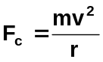  For slip,  F_{c} > F_{f}  So use F_{c} = F_{f} | 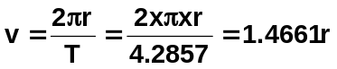  Know F_{c} = F_{f} and  So use F_{c} to find r  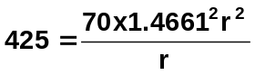  425 = 150.5r  r = 2.82 m  therefore at 2.82 m, F_{c} = F_{f}, at greater radius, velocity will increase and so will F_{c} so person will be thrown off.

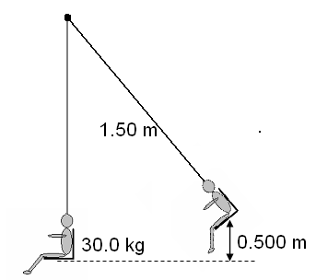
Example:
A child is sitting on a swing and has been pulled back so that the seat is 0.500 m above the lowest point in the swing. The seat is then released.
- Calculate the velocity of the swing at its lowest point.
- Calculate the tension in the ropes of the swing when a 30.0 kg child is moving through the lowest point in the swing, which has a length of 1.50 m.

E_{p} lost = E_{k} gained  mgh = ½ mv²  masses cancel  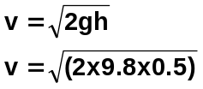  v = 3.13 ms⁻¹ | at the lowest point, F_{T} = F_{c} + F_{w}  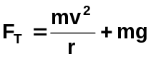  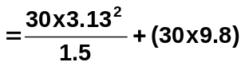  F_{T} = 196 + 294  = 490  tension = 4.90 x 10² N

Exploring Physics Stage 3:
- Experiment 3.1

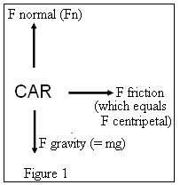
Going around a circular curve Text Reference pg. 37-40
Why do road and race track designers sometimes bank the road when it curves?

When a car rounds a curve that is horizontal, the frictional force between the tyres and road surface supply the necessary centripetal force. The reaction force (or normal) is the force of the road on the car due to its weight (mg). See Figure 1.

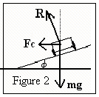
If the road is banked at an angle to the horizontal as shown in Figure 2, the horizontal component of the reaction force, R, supplies the centripetal force. The vertical compound of R is equal to the weight of the car. See Figure 3.

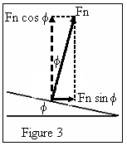
In other words, the banking of curves can reduce the chance of skidding because the normal force of the road will have a component towards the centre of the circle thus reducing the need for friction. For a given angle of banking, there will be one speed for which no friction at all is required. This will be the case when the horizontal component of the normal force, Fn sin φ, is just equal to the force required to give a vehicle its centripetal acceleration – that is when Fn sin φ = mv²/r The banking angle of a road, φ, is chosen so that this condition holds for a particular speed, called the “design speed”. Which is why you shouldn’t speed around curves as they have been designed for a particular maximum speed!

From Figure 2, the reaction force can be resolved into its compounds as shown below and from the triangle you can see that:

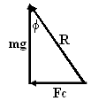
tan φ = Fc = mv²/r
mg mg

so tan φ = v² where φ = angle of track
rg v = optimum
speed for banked track
r = radius of curvature
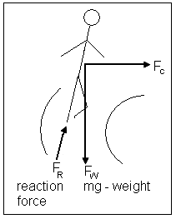
g = 9.8 ms⁻²

A typical type question could be, given and the angle and radius of a bank, what is the maximum speed for this bank. Or you could be asked to compare two situations, one in which a curve is not banked and one in which it is and compare the maximum speeds.

Helpful Hint: The formula above can also be used for objects that lean on a flat surface e.g. runners going around a corner will lean to enable them to increase their speed, likewise, motor cycles will lean when going around bends for the same reason.

Example:
A civil engineer has to design a road in which there is a curve with a radius of 3.00 x 10² m. The road will have a maximum speed limit of 1.10 x 10² kmh⁻¹. At what angle should the road bank on the curve so that no frictional force is needed by a vehicle, travelling at the speed limit, to move round it.

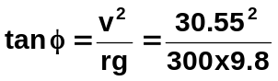r = 300 m
v = 110 kmh⁻¹
= 30.55 ms⁻¹
g = 9.8 ms⁻¹ tan φ = 0.3175
φ = 17.6⁰

Increasing Angle But Maintaining The Same Speed:
The diagram below shows how the different tensions can be calculated when the circular motion is not horizontal. The situation is swinging a ball ready to release such as in hammer throwing at athletic events.
At the highest point, gravity is helping as the ball starts to fall so there is less tension in the wire:

Ft = Fc - Fw
Ft = Fc - Wsin φ

At lowest point, gravity needs to be overcome as the ball raises so
tension is higher:

Ft = Fc + Fw
Ft = Fc + Wsin φ

Example:
A hammer thrower is swinging his 7.25 kg hammer at an angle of 40.0⁰ to the horizontal at a speed of 10.0 ms⁻¹. If the length of his arms are 0.500 m and the length of the wire is 0.700 m, calculate:
              - the centripetal acceleration.

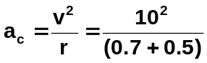

a_{c} = 83.3 ms⁻²

              - the centripetal force.
F = ma_{c}
= 7.25 x 83.3
F = 604 N

              - the tension in the wire at the top of the swing just as the ball is on the way down.
F_{w} = W sin φ F_{T} = F_{c} – F_{W}
= mg sin 40 = 604 – 45.67
= 7.25 x 9.8 x sin 40 F_{T} = 558 N
= 45.67 N

              - The tension in the wire at the bottom of the swing just as the ball is on the way up.

F_{T} = F_{c} + F_{w}
= 604 + 45.67
F_{T} = 650 N

A Vertical Circle Text Reference pg. 42-47

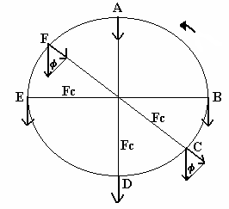

In a horizontal circle, the force applied is always constant. However, in a vertical circle the force of gravity must be considered. As gravity is the same value and always acts downwards sometimes it assists the motion and sometimes it acts against the motion. Consider each of the points above on a vertical circle turning anticlockwise.

A - gravity helps so Ft = Fc - W
Ft = Fc - mg

B - no component of Fc so Ft = Fc

C - component added to Fc so Ft = Fc + Fw
Ft = Fc + W sin φ

D - gravity adds force so Ft = Fc + W
Ft = Fc + mg

E - same as B

F - Component along Fc so Ft = Fc - Fw
Ft = Fc - W sin φ
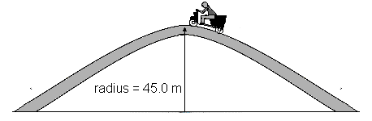
Your text page 183 gives an example.

Example:
A hump back bridge is constructed so it has a radius of 45.0 m. What is the maximum speed a motorcyclist can travel across the bridge without ‘lifting off the bridge’?
For the motorcyclist not to lift off,
F_{c} = F_{w}
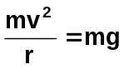 masses cancel
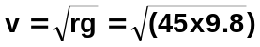
v = 21.0 ms⁻¹ (75.6 kmh⁻¹)
Exploring Physics Stage 3:
- Set 3 Circular Motion
- Investigation 3.2 (home research)
Text Questions page 49-51
Outcome 8: describe and interpret the radial gravitational field distribution around a single (point) mass

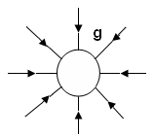
Diagrammatic representation of gravitational fields pg. 59
We can describe a field as an area in which an object will experience a force. You have already drawn electrical fields around charged particles in Stage 2 Physics; Electrical Fundamentals, this is no different. Gravitational fields are regions in which a mass will experience a force. The diagram to the right shows the radial gravitational field distribution around an object, for example, the Earth.

- Gravitational forces are vector quantities and can be represented by vector arrows.
- The arrow shows that the direction of the gravitational force is towards the object.
- The more arrows, the greater the mass of the object and therefore the greater the gravitational field.
- The closeness of the arrows indicates the size of the field at any point within the field.

Most fields obey the “inverse square rule” which is that the force is proportional to the inverse of the distance squared:
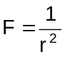. Gravitational fields are no different.

Example:
Consider the two field diagrams that represent the gravitational fields around two planets O and P which have the same radius. X represents a mass which is exactly the same distance above the planets.

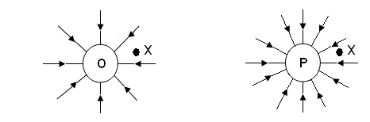

Which of the following statements is true? Where the statement is false, write in a correct answer. If true, justify your answer.

- The planets have the same radius so must have the same acceleration due to gravity at the surface of the planets.

False: The acceleration due to gravity is determined by the mass, not the radius. The field lines indicate that planet P has the larger acceleration due to gravity.
- The gravitational force is weaker on mass ‘X’ above planet P.
False: The field lines are closer together at point X for planet P so the field is stronger than for planet O.
- The mass of planet O is less than the mass of planet P.
True: the lower number for field lines and the larger distance between them indicates a weaker field strength so less mass.
Outcome 9: explain and apply Newton's Law of Universal Gravitation and the concept of gravitational acceleration, g, as gravitational field strength—this will include applying the relationships:

Gravitation Fields and Universal Gravitation
Consider a tower several miles high with a horizontal canon on top. The velocity at which the cannon ball is fired is increased every time.

Each time it falls back to the ground except the last time where it keeps falling towards the Earth but the Earth curves away from it as it falls. It is in orbit.

All satellites, both artificial and natural, are in free fall and their acceleration depends only on where they are. Close to Earth the acceleration is 9.8 ms⁻². In much higher orbits they move slower and have a lower acceleration.

Gravitational Fields Text Reference pg. 54-62

Newton’s talent for clear thinking provided most of the logical framework for our modern understanding of motion of everyday objects. He explained the forces which attract falling objects towards the Earth and why satellites stay in orbit. He found that all object attract each other with a force which is proportional to the product of their masses and inversely proportional to the square of their distance apart.

So 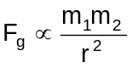

This is known as Newton’s Law of Universal Gravitation.
To turn a proportionality into an equation you need to add a constant, in this case, G – the gravitational constant.
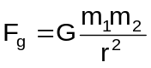 where F_{g} = force in newtons (N)
m₁ & m₂ = masses of objects (kg)
r = distance apart (m)
G = gravitational constant, 6.67 x 10⁻¹¹ Nm²kg⁻²
Your teacher will work through the following examples with you.
Helpful hint: A common error for students is to forget to square the radius.

Example:
The mass of the Earth is 6.00 x 10²⁴ kg. If the centres of the Earth and moon are 3.90 x 10⁸ m apart, the gravitational force between them is about 1.90 x 10²⁰ N. What is the approximate mass of the moon.
m_{E} = 6.0 x 10²⁴ kg 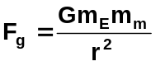
1.9 x 10²⁰ =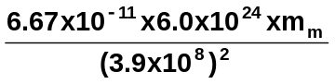
m_{m} = 7.22 x 10²² kg

Example:
Calculate the force of attraction between yourself and your nearest neighbour. List your assumptions.

Helpful Hint: When dealing with estimation questions, you must make reasonable estimates. For example, you could estimate your friend’s mass as 60 kg or 65 but not 64.5 kg – this is too accurate for an estimate. Most estimate questions have only 1 or 2 significant figures in the answer.

assumptions: 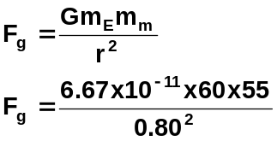
m₁ = 60 kg F_{g} = 3.44 x 10⁻⁷ N
m₂ = 55 kg
r = 0.8 m but as an estimate, F_{g} = 3 x 10⁻⁷ N

Calculating Gravitational Field Strength Text Reference pg. 60-62

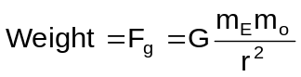We know that the force that causes an object to fall towards Earth is the gravitational force between that object and the Earth, otherwise known as weight. The weight follows the Universal Gravitational Laws hence:

Where m_{E} = mass of Earth and m_{o} = mass of object

Now weight = mass of object x gravity or weight = m_{s}g
So 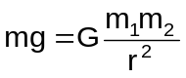
M_{o} cancels out on each side so; 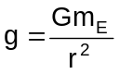 or 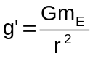 (see note 3 below)
NOTE:
- This implies that the value of “g” is independent of the mass of the object.
- For any object on the Earth’s surface, G, m_{E}, and r are constant so ‘g’ is the same value.
- Values of “g” above the Earth’s surface are often referred to as g’ (g prime) to distinguish them from “g” on Earth.

Example:
Determine the acceleration due to gravity on a rocket of mass 6.0 x 10³ kg when it is on the Earth
and when it is in orbit 250 km above the Earth.
Helpful Hint: Sometimes a value you are looking for is a constant and is found in your data sheet.
Helpful Hint: Don’t forget to change km to m when dealing with distance above Earth and add to radius of Earth (or other large mass).

On Earth:
G = 6.67 x 10⁻¹¹ Nm²kg⁻²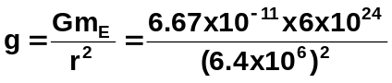
r = 6.4 x 10⁶ m
m_{E} = 6.0 x 10²⁴ kg
g = 9.77 ms⁻²

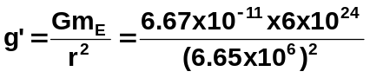In orbit:
G = 6.67 x 10⁻¹¹ Nm²kg⁻²
r = 6.4 x 10⁶ + 250 000
= 6.65 x 10⁶ m
m_{E} = 6.0 x 10²⁴ kg g’ = 9.05 ms⁻²

Exploring Physics Stage 3
- Experiment 4.1
Outcome 10: explain the conditions for a satellite to remain in a stable circular orbit in a gravitational field, and calculate the parameters of satellites in stable circular orbits—this will include applying the relationships:
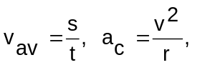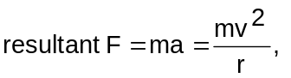.

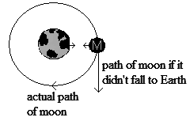
Satellite motion Text Reference pg. 63-70
Newton believed that the force of attraction between the Earth and the Moon made the Moon continually fall towards the Earth instead of travelling off into space.

The Earth provides a centripetal force on the moon that maintains its circular path around the Earth. This same force explains why planets maintain their orbits around the sun.
From circular motion we know that the centripetal force is equal to 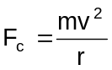
but we also know that the two bodies exert a force on each other
In circular motion these forces are the same value so F_{c} = F_{g}
There 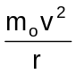 = 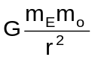; cancel m_{o} then v² = G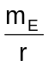
Why Do Satellites Stay in Space?
- It must be high enough above the Earth so that it escapes falling back to Earth.
- Its horizontal velocity must be such that it makes a complete circular orbit of the Earth. Any less, it falls to Earth, any more, it escapes orbit.
Note: At this point the tangential velocity is perpendicular to the force of gravity and travelling parallel to the curve of the Earth – no component of ‘g’ to change the speed.
- As centripetal force pulls the satellite to Earth it continually falls down towards the Earth’s surface which is itself continually curving away. The satellite swings in a circle above the Earth at a constant distance.
- Mathematically for a stable orbit, F_{c} = F_{g},

Gravitational Force Fields
Remember, a force field can be thought of as a region of influence. Each body in space has its own force field and any object travelling in space experiences these forces. The nearer to the body an object moves, the stronger the gravitational pull and visa versa.

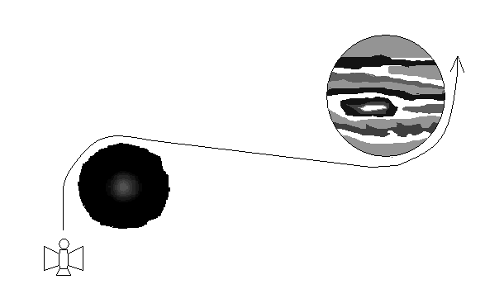
Space travel has to take into account the effects of numerous gravitational fields. These can hinder progress by pulling a spacecraft off course or be used to advantage to sling-shot a craft into a new course without the use of fuel. Many space probes use the “sling-shot” approach when exploring our solar system to both change direction and increase speed.

Main formulas for satellites are:
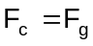; 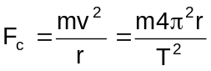; ; 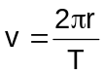
these can be used to derive the following:
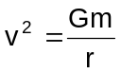; 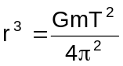; 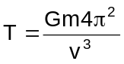
you should know how to derive these! (See pages 65-68 of text.)
Outcome 11: describe and explain the impact of satellites and associated technologies on everyday life

Read page 70 of your text, Physics Content and Contexts Units 3A & 3B, and also appropriate websites on satellites and write notes on the impact of satellite technology on our world. Be prepared to use this research to make a mind map during class time.

Revision Questions ANSWERS from page 26
- A car is travelling at 72.0 kmh⁻¹ East when it rounds a corner to finally be travelling at 64.8 kmh⁻¹ North. If the change of velocity took place in 1.56 s, what was the car’s acceleration?

- A light plane, flying at 20.0⁰ above the horizontal has an airspeed of 136.8 kmh⁻¹. Find the plane’s rate of climb (vertical velocity).

- You are travelling in a hot-air balloon at 7.00 ms⁻¹, which is the same speed as the wind. If you hold a small flag in your hand, which way will the flag wave? Briefly explain.

- The pilot of a small plane is flying feedstock (bails of hay) to a stranded flock of sheep, trapped by rising floodwaters. The pilot skilfully flies at an altitude of 1.00 x 10² m when, travelling at 151.2 kmh⁻¹ horizontally, she releases a bail of hay. How far horizontally from the flock of sheep must she release the feedstock so that the bail of hay strikes the ground just before the sheep?

- a. An archer fires an arrow from a height of 1.20 m above the ground. If the initial velocity of the arrow was 32.0 ms⁻¹, and the archer fires the arrow at an angle of 28⁰ to the ground. How far away from him will the arrow hit the ground?

  - Explain one way in which the archer could have fired the arrow a greater distance without increasing the initial velocity.

- At the Olympics, a hammer thrower spins the 7.26 kg hammer in a horizontal circle of radius 1.45 m, rotating 10 times every 13.4 s. The hammer thrower’s arms make a straight line with the hammer handle and at this speed the hammer makes an angle of φ to the horizontal as shown in the diagram.
  - Calculate the centripetal force on the hammer.
  - Calculate the tension in the wire handle of the hammer.
  - Calculate the angle φ.

- A toy designer is in the process of designing a “loop the loop” racetrack for small toy cars. The designer is neglecting friction during the initial design phase. A sketch of the planned track is shown. Perform the necessary calculations that would show the starting height, h, required for the car to just complete one loop.

- A cyclist racing at a velodrome can corner at a speed of 60.0 kmh⁻¹ around a 40.0 m radius bend that is banked. Calculate the angle of the track to the horizontal.

- A planet with a small radius, A, has a large mass while a planet with a large radius, B, has a lower mass. Draw the fields around each planet.

- A satellite is orbiting 270 km above the Earth. Determine the acceleration due to gravity on the satellite.

- Calculate the force between the Earth and the Moon.

Exploring Physics Stage 3
- Set 4 Gravitation and Satellites
Outcome 12: explain and apply the concept of torque or moment of a force about a point, and the principle of moments, and their application to situations where the applied force is perpendicular to the lever arm—this will include applying the relationships: .

Torque and Equilibrium

All structures can experience forces, some of these forces are:
- COMPRESSION - this is a squashing force
- TENSION - this is a stretching force (sometimes referred to as a tensile force)
- SHEARING - this is a sideways force
- TORSIONAL STRESS - a twisting force
- BENDING FORCES - usually looked at in beams under load.

A review of centre of mass
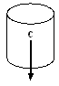
The closer the centre of mass of an object is to the ground and the larger the base, the more stable the object is. Greatest stability comes from low centre of mass and large area (base) over which the centre of mass acts. A large force is then required to move the centre of mass beyond the base.

Stable:
Stable position with centre of mass over the base. Slight movement has no overall effect - centre of mass may be raised but object returns to its original position

Unstable:
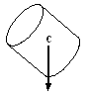
Centre of mass is over the pivot. Slight movement causes object to move resulting in a new, often lower, centre of mass.

Neutral:
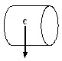
Centre of mass is over the pivot. Slight movement causes object to move
to a new position although the centre of mass usually remains at the
same height.

Work through these questions with your teacher.
Moment of a Force or Torque
1. Explain why you pick up a long object at the centre. In the centre the mass is evenly distributed around your hand and it is easier to hold
2. Give some examples of a turning force.
pushing open a door, bike peddles, opening lids on jars,
3. What is the name given to this turning force? moment of a force or torque
4. Three factors affect the amount of turning force, they are:
a. magnitude of the applied force
b. perpendicular distance from the pivot point the force acts, r⊥
c. angle between lever arm and force which affects the size of the perpendicular distance
5. Explain the equation M = Fr⊥ (also τ = Fr⊥ )
the moment or torque is equal to the force multiplied by the perpendicular distance
What are the units for moment? Nm
6. What is a cantilever? free part of a structure that projects beyond the point of support
Diagram: cantilever
support often used in bridges,
and to provide shade in
sporting venues

Torque Text Reference pg. 72-75
A torque or moment of a force is a turning effect created when a linear force is applied to a leaver arm with a pivot and the object rotates. In this course, the linear force is applied perpendicular to the lever arm so the formula is:
τ = F x r⊥ where τ = torque or moment in Nm
F = applied force at 90⁰ in N
r⊥ = perpendicular distance of point of
application of force from pivot point

Example:
You pick up a hammer which has a mass of 1.25 kg. You are holding it 15.0 cm from the centre of mass. What is the value of the moment of force you are applying to keep the hammer horizontal?

F = mg Always draw a diagram τ = Fr⊥
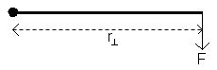
= 1.25 x 9.8 = 12.25 x 0.150
= 12.25 N = 1.8375
r = 0.150 m τ = 1.84 Nm

Activity:
Jasmine, who has a mass of 35.0 kg, is sitting on a uniform seesaw which is 5.00 m long and pivoted in the middle. She is sitting 0.545 m from one end. What torque does she produce?

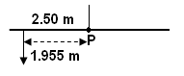
F = mg t = Fr⊥
= 35 x 9.8 = 343 x 1.955
= 343 N τ = 670.565 Nm

τ = 671 Nm

Activity:
A 24.0 kg pelican is sitting at the end of a uniform horizontal support pole for a street lamp The support pole is 0.750 m long and has a mass of 10.0 kg. Calculate the torque on the pivot point of the street lamp.

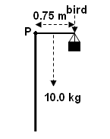
here the pole has two forces, bird and weight of pole.

τ = (Fr⊥) _{bird} + (Fr⊥) _{pole}
= (24 x 9.8 x 0.75) + (10 x 9.8 x 0.375)
= 176.4 + 36.75
= 213.15

τ = 213 Nm

Exploring Physics Stage 3
- Experiment 5.1

Resolving Vector Forces
You need to have an understanding of resolving vector forces.
Your teacher will work through the example below with you.
Example:
A street lamp weighing 50 kg, hangs from two poles as shown below. Calculate the tension in each wire.
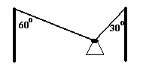
Answer:
1. Firstly resolve the forces into horizontal and vertical components.
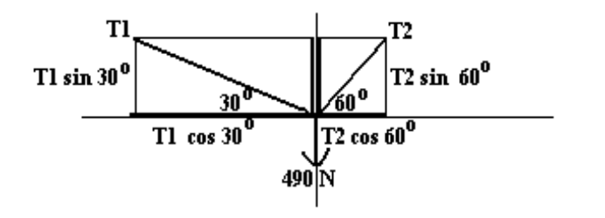
2. Then add the horizontal forces. As the lamp is not moving, we know that the left side minus the
right side must equal zero (ΣX = 0).

T1 cos 30⁰ - T2 cos 60⁰ = 0
0.866 T1 - 0.5 T2 = 0
therefore T1 = 0.5774 T2 → equation 1

3. Then add the vertical forces. As the lamp is not moving, we know that the sum of the forces must
be zero (ΣY = 0)

T1 sin 30⁰ + T2 sin 60⁰ - 490 = 0
0.5 T1 + 0.866 T2 - 490 = 0 → equation 2

substitute equation (1) into equation (2)

0.5 (0.5774 T2) + 0.866 T2 - 490 = 0
0.2887 T2 + 0.866 T2 - 490 = 0
1.1547 T2 - 490 = 0
T2 = 424 N

4. Substitute for T2 back into equation (1)

T1 = 0.5774 T2
= 0.5774 x 424
= 245 N

5. Write down answer: T2 = 424 N
T1 = 245 N

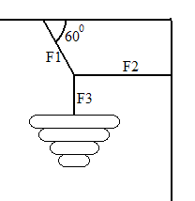Example 2: Try this one yourself
A chandelier is hanging from a ceiling as shown. The mass of the chandelier is 200 kg. Find the forces F1, F2 and F3.

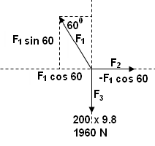

Vertical forces

F₁ sin 60 = 1960 F₃ = weight = 200 x 9.8
F₁ = 1960 ÷ sin 60 F₃ = 1.96 x 10³ N down
F₁ = 2263 N

F₁ = 2.26 x 10³ N 60⁰ to horizontal
Horizontal forces

F₂ = F₁ cos 60
= 2263 x 0.5 F₂ = 1.13 x 10³ N right
= 1132 N

Exploring Physics Stage 3
- Experiment 1.2

Conditions for Equilibrium Text Reference pg. 77-89
The simplest turning situation is a seesaw. The point about which the turning occurs is called the fulcrum or pivot. The Magnitude of the weights (force) placed either side of the fulcrum as well as where the weights are placed (perpendicular distance of force) can cause an imbalance. When a turning force is in balance e.g. in a seesaw balanced horizontally with masses on either side, we say that it is in a state of stable (or static) equilibrium.

At this point two conditions exist. The sum of the forces equals zero and the sum of the moments equals zero.
            ΣM = 0
sum of the clockwise moments = sum of anti-clockwise moments
ΣCM = ΣACM

ΣF = 0
sum of forces up = sum of forces down
ΣF_{up} = ΣF_{down}

Example 1: A boy of mass 45.0 kg sits 1.50 m from the pivot point of a seesaw on the right hand side. Where must a girl of mass 40.0 kg sit in order for the seesaw to balance?

take moments about P
for balance ΣM = 0
Always draw a diagram BOY F = ma therefore ΣCM = ΣACM
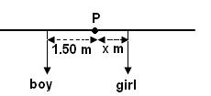
F = 45 x 9.8 Fr⊥ (boy) = Fr⊥ (girl)
F = 441 N 441 x 1.5 = 392 x r (girl)
r⊥ = 1.5 m r (girl) = 441 x 1.5
GIRL F = 40 x 9.8 392
F = 392N r (girl) = 1.69 m
r⊥ = ?
Girl is sitting 1.69 m from the left of the centre (fulcrum)

Helpful Hint: Always state where you are taking the moments from. This is particularly important in your WACE Examination. In last year’s TEE, 1 mark was given for this in a difficult question.

Your teacher will work through the following examples with you.

Example 2:
A man weighing 840 N sits on a seesaw 1.50 m from the pivot. His son and daughter sit on the other side and balance it. The girl weighs 4.20 x 10² N and is 0.900 m from the pivot. What is the weight of the boy who sits 1.80 m from the pivot?
take moments about P
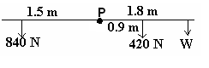
ΣM = 0
ΣCM = ΣACM
(420 x 0.9) + (W x 1.8) = (840 x 1.5)
378 + 1.8W = 1260
1.8 W = 882
W = 490 N

the weight of the boy is 490 N

Example 3:
A man holds a 50.0 N ball in his arm as shown below. The pivot point is the elbow and the forearm weighs 15.0 N. Calculate the force the muscles (M) must apply for the arm to hold the ball horizontal.
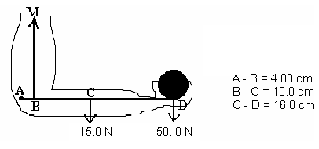

Additional information:

A-B = 0.04 m
B-C = 0.10 m
C-D = 0.16 m
A-C = 0.14 m
A-D = 0.30 m

ΣM = 0
ΣCM = ΣACM
(15 x 0.14) + (50 x 0.3) = (m x 0.04)
2.1 + 15 = 0.04 m
17.1 = 0.04 m
m = 427.5 force of muscle = 428 N

Example 4:
What are the forces F₁ and F₂ that the supports exert on the diving board shown in the diagram below, when a 45.0 kg girl stands at the end of the board, if the mass of the board is 25.0 kg?
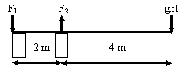

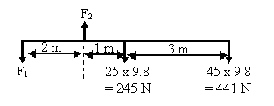
1. Firstly, always redraw diagram.

take moments about F₂  can you suggest why?  ΣM = 0  ΣCM = ΣACM  (245 x 1.0) + (441 x 4) = F₁ x 2  245 + 1764 = 2F₁  2009 = 2F₁  F₁ = 1004.5 N down | Now at equilibrium, the sum of the forces is zero so ΣF up = Σ down  F₂ = F₁ + F_{w} + F _{girl}  = 1004.5 + 245 + 441  F₂ = 1690.5 N up  so F₁ = 1.00 x 10³ N down  F₂ = 1.69 x 10³ N up

Helpful Hint: Forces are vector quantities so you should include a direction.

Before we continue, a suggested approach to problem solving
Follow this procedure in all problems and you will find them easier to do. Marks are awarded for working and if you go through this process you can often get more than 50% of the marks, even if you cannot solve the equations, perhaps even if you get the equations wrong. You must always show all working.

- Read question carefully and form a mental picture of the situation then identify the object that is in equilibrium including its pivot point.
- Draw a large clear fully labelled diagram. Use a ruler and pencil.
- Identify the forces acting on the object that is in equilibrium and put them in the diagram in correct position.
- Identify the unknown forces and angles required by the question and mark them in the diagram. Give them a symbol.
- Check that you have all the forces correctly shown. Show only forces acting on the object in question.
- Take moments about the point of action of the force with unknown direction (if applicable).
- Equate the components of the forces horizontally and vertically to zero. ΣF_{H} = 0 ΣF_{V} = 0
- Solve for the unknowns. Be careful with the mathematics.
- Give direction of vector. Check you have the correct number of significant figures & the correct units.

Back to equilibrium
We know that for a body to be in equilibrium (not moving at all),
ΣM = 0 (sum of moments equals zero) and ΣF = 0 (sum of forces equals zero).
These are known as the conditions for equilibrium.

Your teacher will work through the following with you giving you clear steps to follow and a better understanding of equilibrium.

Example 1:
The diagram below shows a sign handing in front of a shop. If the sign weighs 2.40 x 10² N and the angle the rope makes with the bar is 55⁰ (angle near the coffee sign), how much tension is in the rope? (Assume the bar weighs 5.00 kg and is 0.800 m long.)

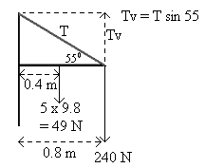
take moments about pivot
ΣCM = ΣACM
(49 x 0.4) + (240 x 0.8) = T sin 55 x 0.8
19.6 + 192 = 0.6553T
211.6 = 0.6553T

T = 3.23 x 10² N

Helpful Hint: When dealing with angles in moments, students sometimes forget to multiply by the distance. For example, in the example above, the anticlockwise moment is (T sin 55 x 0.80)

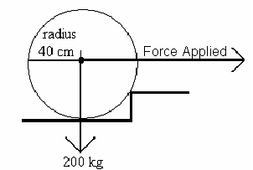
Example 2:
A lawn roller of mass 2.00 x 10² kg and radius 40.0 cm is being pulled over a step as shown. The step is 8.00 cm high and the handle is horizontal.
- What force is required to cause the roller to begin moving
- At what angle to the horizontal will the least force be needed to pull the roller over the step. Justify your answer with appropriate calculations.
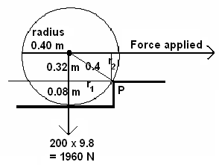

0.4² = r₁² + 0.32²
r₁ = 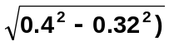
r₁ = 0.24 m
r₂ = 0.32 m

a. Take moments about P
ΣCM = ΣACM
F x r₂ = F_{w} x r₁
F x 0.32 = 1960 x 0.24
F = 1470

F = 1.47 x 10³ N

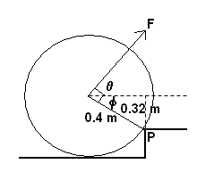
the least amount of force will be when the applied force is perpendicular to the radius of the roller.

φ = sin⁻¹ (0.32 ÷ 0.40)
= 53.13⁰

θ = 90 – 53.13
= 36.9⁰

so minimum force is when force is 36.9⁰ above horizontal.

Example 3:
A 20.0 m long bridge is supported at each end by pillars. The bridge has a mass of 3.52 x 10⁴ kg. On the bridge is a truck which has a mass of 2.60 x 10³ kg and a car which has mass of 985 kg. The truck is 4.00 m from one end and the car is 5.00 m behind the truck. Calculate the force on each pillar.
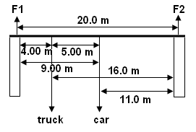
F car = mg = 985 x 9.8 = 9653 N
F truck = 2600 x 9.8 = 25480 N
F bridge = 3.52 x 10⁴ x 9.8 = 318500 N

take moments about F1 F up = F down
ΣCM = ΣACM F1 + F2 = truck + car + bridge
(25480 x 4) + (9653 x 9.00) + (318500 x 10) = F2 x 20 F1 + 168690 = 9653 + 25480 + 318500
101920 + 86877 + 3185000 = 20F2 F1 + 168690 = 353633
3373797 = 20F2 F1 = 184943
F2 = 168689.85 N
F1 = 1.69 x 10⁵ N up
F2 = 1.85 x 10⁵ N up

Exploring Physics Stage 3
- Experiment 5.2

Questions:
- If you stand with your left side and left foot against the wall you will fall over if you lift your right foot. Explain, using the concept of torque then estimate the amount of torque causing you to fall over in the situation described above.
Stability comes when the centre of mass is within the base of the object. The centre of mass of a person is between their feet when standing upright so no torque. When you lift your right foot, your centre of mass is outside your base (your left foot) and therefore a torque is provided by your weight and you will fall over or more correctly, rotate.
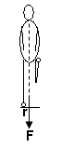
r = 0.1 m τ = Fr
F = 60 x 9.8 = 588 x 0.1
= 588 N = 58.8

τ = 60 Nm

- A long bridge of mass 1.00 x 10⁴ kg is supported by two large columns as shown. The centre of mass of each column is 24.0 m apart. If a 9.00 x 10² kg car is two-thirds of the way across the bridge, what is the force each column is supporting?
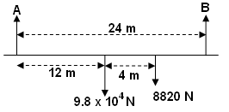
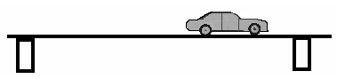

take moments about A
ΣCM = ΣACM
(9.8 x 10⁴ x 12) + 8820 x 16) = B x 24
1.176 x 10⁶ + 14112 = 24B
1317120 = 24B
B = 5.49 x 10⁴ N up

F up = F down
A + 54880 = 9.8 x 10⁴ + 8820
A = 9.8 x 10⁴ + 8820 – 54880
A = 5.19 x 10⁴ N

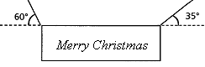
- A large uniform sign of mass 40.0 kg is suspended over Victoria Street in Bunbury as part of the Christmas decorations. It is supported by two cables attached to buildings either side of the street. Calculate the tensions in the cables.
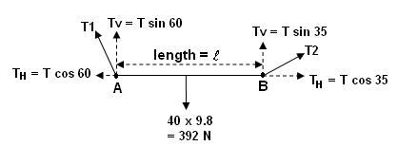

take moments about A  ΣCM = ΣACM  392 x ½  = T₁ sin 35 x    cancel so  392 x 0.5 = T₁ sin 35  196 = 0.5736T  T₁ = 341.7  T₁ = 3.42 x 10² N | Take moments about B  ΣCM = ΣACM  (T₂ sin 60 x ) = (392 x ½ )  again  cancels  T₂ sin 60 = 392 x 0.5  0.866T₂ = 196  T₂ = 226.3  T₂ = 2.26 x 10² N

NOTE: You will not have questions involving resolution of forces with a moments problems but this problem does show how the two concepts work together.

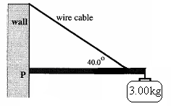
- The diagram shows a wall bracket used to hang a sign from a wall. The dimensions of the wall bracket are as follows:
Mass beam = 1.50 kg
Length beam = 1.00 m
Wire attached 0.750 m along beam
Find:
a. The tension in the wire cable.
b. The compression in the beam.
c. The reaction at the wall, point P.

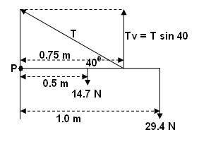
a.
Take moments about P
ΣCM = ΣACM
(14.7 x 0.5) + (29.4 x 1.0) = (T sin 40 x 0.75)
7.35 + 29.4 = 0.482T
36.75 = 0.482T
T = 76.2 N

b. Compression in the beam is the horizontal component of tension force.

T_{H} = T cos 40
= 76.24 x cos 40
= 58.4 N
compression = 58.4 N to the left

c. Reaction force is sum of horizontal and vertical components.

Horizontal is (b) above = 58.4 N left

Vertical: (14.7 + 29.4) down – (T sin 40) up
44.1 (down) – 48.98 (up)
4.88 N up

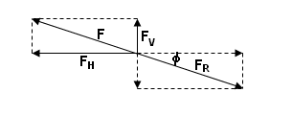
F_{R} = 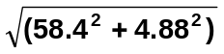
= 58.6 N
φ = tan⁻¹ (4.88 ÷ 58.4)
= 4.78⁰

F_{R} = 58.6 N 4.78⁰ below horizontal

Exploring Physics Stage 3:
- Set 5: Moments and Equilibrium

Text Questions page 90-91
Task 7: Test Motion and forces in a gravitational field
ANSWERS: Revision Questions page 14
- A car is travelling at 72.0 kmh⁻¹ East when it rounds a corner to finally be travelling at 64.8 kmh⁻¹ North. If the change of velocity took place in 1.56 s, what was the car’s acceleration?
u = 72 kmh⁻¹ 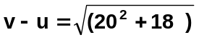
= 20 ms⁻¹ east = 26.91 ms⁻¹
v = 64.8 kmh⁻¹ φ = tan⁻¹ (20 ÷ 18)
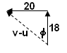
= 18 ms⁻¹ north = 48.0⁰
v-u = 18 N – 20 E 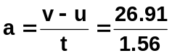
= 18 N + 20 W a = 17.25
t = 1.56 s a = 17.3 ms⁻² N 48⁰ W

- A light plane, flying at 20.0⁰ above the horizontal has an airspeed of 136.8 kmh⁻¹. Find the plane’s rate of climb (vertical velocity).
v = 136.8 kmh⁻¹ v_{v} = V sin 20
= 38 ms⁻¹ = 38 sin 30
v_{v} = 13.0 ms⁻¹

- You are travelling in a hot-air balloon at 7.00 ms⁻¹, which is the same speed as the wind. If you hold a small flag in your hand, which way will the flag wave? Briefly explain.
As you are moving at the same speed and direction as the wind, no n et horizontal force on the flag so the flag hangs limp;

wind
speed of flag relative to balloon is zero.
balloon as no wind, flag is limp

- The pilot of a small plane is flying feedstock (bails of hay) to a stranded flock of sheep, trapped by rising floodwaters. The pilot skilfully flies at an altitude of 100.0 m when, travelling at 151.2 kmh⁻¹ horizontally, she releases a bail of hay. How far horizontally from the flock of sheep must she release the feedstock so that the bail of hay strikes the ground just before the sheep?
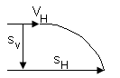
s_{v} = 100 m s_{v} = u_{v}t + ½ gt² s_{H} = v_{H} x t
v_{H} = 151.2 kmh⁻¹ 100 = 0 + 4.9t² = 42 x 4.5175
= 42 ms⁻¹ t = 4.5175 s s_{H} = 189.74 m
g = 9.8 ms⁻¹ need to release hay 190 m from sheep.

- a. An archer fires an arrow from a height of 1.20 m above the ground. If the initial velocity of the arrow was 32.0 ms⁻¹, and the archer fires the arrow at an angle of 28⁰ to the ground. How far away from him will the arrow hit the ground?
b. Explain one way in which the archer could have fired the arrow a greater distance without increasing the initial velocity.
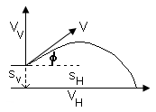
a.
s_{v} = -1.20 m v_{v}² = u_{v}² + 2gs
g = -9.8 ms⁻¹ = 15.023² + (2 x -9.8 x -1.2)
u_{v} = 32 sin 28 = 225.69 + 23.52
= 15.023 ms⁻¹ = 249.21
u_{H} = 32 cos 28 v_{v} = 15.786 ms⁻¹ down
= 28.254 ms⁻¹ t = (v-u) ÷ g
= (-15.786-15.023) ÷ 9.8
= 3.1438 s

s_{H} = 28.254 x 3.1438
s_{H} = 88.8 m

b. Increase angle to around 45⁰

- At the Olympics, a hammer thrower spins the 7.26 kg hammer in a horizontal circle of radius 1.45 m, rotating 10 times every 13.4 s. The hammer thrower’s arms make a straight line with the hammer handle and at this speed the hammer makes an angle of φ to the horizontal as shown in the diagram.
  - Calculate the centripetal force on the hammer.
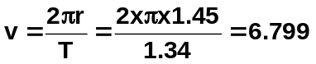r = 1.45 m
T = 13.4 ÷ 10
= 1.34 s
m = 7.26 kg 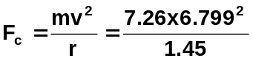
F_{c} = 231 N

  - Calculate the tension in the wire handle of the hammer.
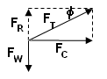
F_{w} = mg = 7.26 x 9.8 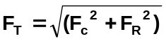
= 71.148 N =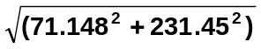
F_{R} = reaction to weight F_{T} = 242 N
equal magnitude

  - Calculate the angle φ.

φ = tan⁻¹ (71.148 ÷ 231.45)
φ = 17.1⁰

- A toy designer is in the process of designing a “loop the loop” racetrack for small toy cars. The designer is neglecting friction during the initial design phase. A sketch of the planned track is shown. Perform the necessary calculations that would show the starting height, h, required for the car to just complete one loop.

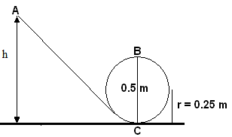
Total energy throughout system is conserved
E_{T} at A = E_{K} + E_{P} but E_{k} = 0 so
= mgh(A)
E_{T} at B = E_{k} + E_{p}
= ½ mv² + mgh(B)

now as in a circle and need minimum velocity to maintain circle, F_{c} = F_{w} (weight)
so equating formulas: v² = rg at point B

now total energy, E_{T}, is constant therefore energy at A
must equal energy at B
mgh(A) = ½ mv² + mgh (B)
also v² at B = rg so
mgh(A) = ½ mrg + mgh(B)
g and m will cancel throughout
h(A) = ½ r + h(B) and height at B = 0.5 m so
h(A) = (½ x 0.25) + 0.5
= 0.625 m

so release height for car is 0.625 m

- A cyclist racing at a velodrome can corner at a speed of 60.0 kmh⁻¹ around a 40.0 m radius bend that is banked. Calculate the angle of the track to the horizontal.
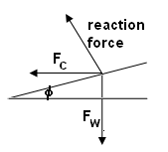
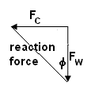
F_{w} = mg
v = 60 ÷ 3.6 = 16.666 ms⁻¹

tan φ =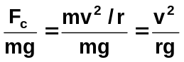
tan φ =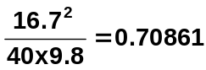
φ = 35.2⁰

- A planet with a small radius, A, has a large mass while a planet with a large radius, B, has a lower mass. Draw the fields around each planet.
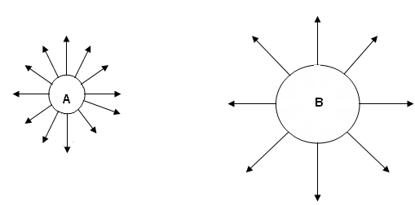

- A satellite is orbiting 270 km above the Earth. Determine the acceleration due to gravity on the satellite.
r_{T} = r_{E} + r_{s} 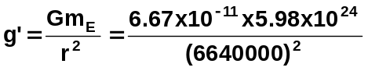
= 6.37 x 10⁶ + 270 000 g’ = 9.05 ms⁻²
= 6 640 000 m
m_{E} = 5.98 x 10²⁴ kg

- Calculate the force between the Earth and the Moon.
r_{E-m} = 3.84 x 10⁸ m 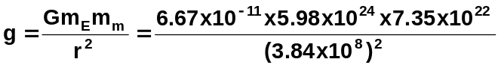
F_{g} = 1.99 x 10²⁰ N
m_{m} = 7.35 x 10²² kg
m_{E} = 5.98 x 10²⁴ kg

- At what speed must a satellite be travelling so that it shall remain in a circular orbit 1.60 x 10³ km above the earth’s surface?
G = 6.67 x 10⁻¹¹ F_{c} = F_{g}
m_{E} = 5.98 x 10²⁴ kg 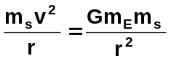
r_{T} = r_{E} + r_{s} m_{s} and r cancels
= 6.37 x 10⁶ + 1 600 000 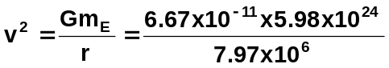
= 7970000 m v² = 50045922
v = 7074

speed = 7.07 x 10³ m

